**ASP.NET Session Management**

Session management is a way in ASP.net to ensure that information is passed over from one page to the other. The view state property of a page is used to automatically pass the information of controls from one page to the other. The 'Session' object is used to store and retrieve specific values within a web page.

The HTTP protocol on which all web applications work is a stateless protocol. By stateless, it just means that information is not retained from one request to another.

For instance, if you had a login page which has 2 textboxes, one for the name and the other for the password. When you click the Login button on that page, the application needs to ensure that the username and password get passed onto the next page.

In ASP.Net, this is done in a variety of ways. The first way is via a concept called ViewState. This is wherein ASP.Net automatically stores the contents of all the controls. It also ensures this is passed onto the next page. This is done via a property called the ViewState.

It is not ideal for a developer to change anything in the view state. This is because it should be handled by ASP.Net only.

**ASP.NET Session object**

The other way is to use an object called a “Session Object.” The Session object is available throughout the lifecycle of the application. You can store any number of key-value pairs in the Session object. So on any page, you can store a value in the Session object via the below line of code.

Session["Key"]=value

This stores the value in a Session object and the ‘key’ part is used to give the value a name. This allows the value to be retrieved at a later point in time. To retrieve a value, you can simply issue the below statement.

Session["Key"]

## ASP.NET Session object Example

In our example, we are going to use the Session object to store the name entered in the name textbox field in the page. We are then going to retrieve that value and display it on the page accordingly. Let’s add the below code to the Demo.aspx.cs file.

[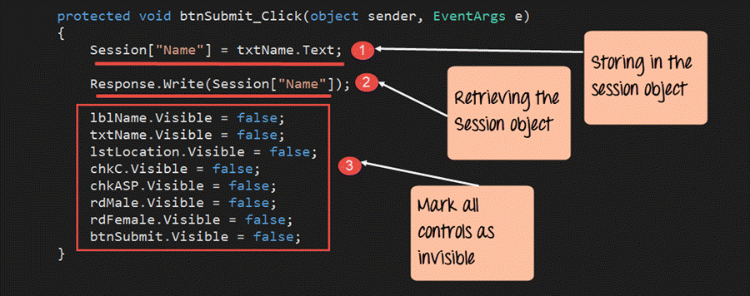](https://www.guru99.com/images/asp-net/061516_0807_ASPNetIntro43.png)

protected void btnSubmit_Click(object sender,EventArgs e)

{

Session["Name"] = txtName.Text;

Response.Write(Session["Name"]);

lblName.Visible = false;

txtName.Visible = false;

1stLocation.Visible = false;

chkC.Visible = false;

chkASP.Visible = false;

rdMale.Visible = false;

rdFemale.Visible = false;

btnSubmit.Visible = false;

}

**Code Explanation:-**

1. The first line of code takes the value of the Name textbox control and stores it in the Session object. By specifying the code of Session[“Name”] , we are giving the property a name called “Name.” By specifying a name for the property, it becomes easier to retrieve it at a later point in time.
2. The next line of code retrieves the stored value from the Session object. It then writes this value via the ‘Response.Write’ method back to the client.
3. Finally, we make all the controls on the form as invisible. If we don’t do this, all the controls plus our response values will be displayed together.

Once you make the above changes, you will see the following output

**Output:**

[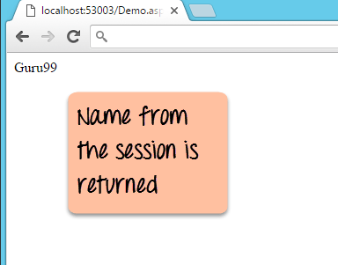](https://www.guru99.com/images/asp-net/061516_0807_ASPNetIntro44.png)

From the output, you can see that the Session value of name was retrieved and displayed in the browser.

**Summary**

* Session management is a way in [ASP.net](https://www.guru99.com/what-is-asp-dot-net.html) to ensure that information is passed over from one page to the other.
* The view state property of a page is used to automatically pass the information of controls from one page to the other.
* The ‘Session’ object is used to store and retrieve specific values within a web page.

# ASP.NET Application & PAGE Life Cycle

**What is ASP.Net Lifecycle?**

When an ASP.Net application is launched, there are series of steps which are carried out. These series of steps make up the lifecycle of the application.

Let’s look at the various stages of a typical page lifecycle of an ASP.Net Web Application.

[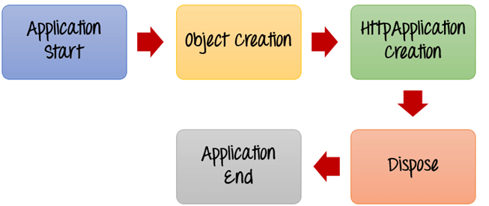](https://www.guru99.com/images/asp-net/061516_0807_ASPNetIntro2.png)

ASP.Net Lifecycle

**1) Application Start** – The life cycle of an [ASP.NET](https://www.guru99.com/what-is-asp-dot-net.html) application starts when a request is made by a user. This request is to the Web server for the ASP.Net Application. This happens when the first user normally goes to the home page for the application for the first time. During this time, there is a method called Application_start which is executed by the web server. Usually, in this method, all global variables are set to their default values.

**2) Object creation** – The next stage is the creation of the HttpContext, HttpRequest & HttpResponse by the web server. The HttpContext is just the container for the HttpRequest and HttpResponse objects. The HttpRequest object contains information about the current request, including cookies and browser information. The HttpResponse object contains the response that is sent to the client.

**3) HttpApplication creation** – This object is created by the web server. It is this object that is used to process each subsequent request sent to the application. For example, let’s assume we have 2 web applications. One is a shopping cart application, and the other is a news website. For each application, we would have 2 HttpApplication objects created. Any further requests to each website would be processed by each HttpApplication respectively.

**4) Dispose** – This event is called before the application instance is destroyed. During this time, one can use this method to manually release any unmanaged resources.

**5) Application End** – This is the final part of the application. In this part, the application is finally unloaded from memory.

**What is ASP.Net Page Lifecycle?**

When an ASP.Net page is called, it goes through a particular lifecycle. This is done before the response is sent to the user. There are series of steps which are followed for the processing of an ASP.Net page.

Let’s look at the various stages of the lifecycle of an ASP.Net web page.

[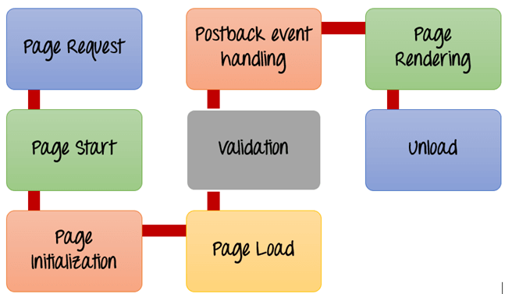](https://www.guru99.com/images/asp-net/061516_0807_ASPNetIntro3.png)

ASP.Net Page Lifecycle

1. **Page Request**– This is when the page is first requested from the server. When the page is requested, the server checks if it is requested for the first time. If so, then it needs to compile the page, parse the response and send it across to the user. If it is not the first time the page is requested, the cache is checked to see if the page output exists. If so, that response is sent to the user.
2. **Page Start** – During this time, 2 objects, known as the Request and Response object are created. The Request object is used to hold all the information which was sent when the page was requested. The Response object is used to hold the information which is sent back to the user.
3. **Page Initialization**– During this time, all the controls on a web page is initialized. So if you have any label, textbox or any other controls on the web form, they are all initialized.
4. **Page Load**– This is when the page is actually loaded with all the default values. So if a textbox is supposed to have a default value, that value is loaded during the page load time.
5. **Validation** – Sometimes there can be some validation set on the form. For example, there can be a validation which says that a list box should have a certain set of values. If the condition is false, then there should be an error in loading the page.
6. **Postback event handling**– This event is triggered if the same page is being loaded again. This happens in response to an earlier event. Sometimes there can be a situation that a user clicks on a submit button on the page. In this case, the same page is displayed again. In such a case, the Postback event handler is called.
7. **Page Rendering**– This happens just before all the response information is sent to the user. All the information on the form is saved, and the result is sent to the user as a complete web page.
8. **Unload**– Once the page output is sent to the user, there is no need to keep the [ASP.net web form](https://www.guru99.com/asp-net-controls-webforms.html) objects in memory. So the unloading process involves removing all unwanted objects from memory.